LDR SENSOR BASED AUTOMATIC LED ON/OFF PROJECT

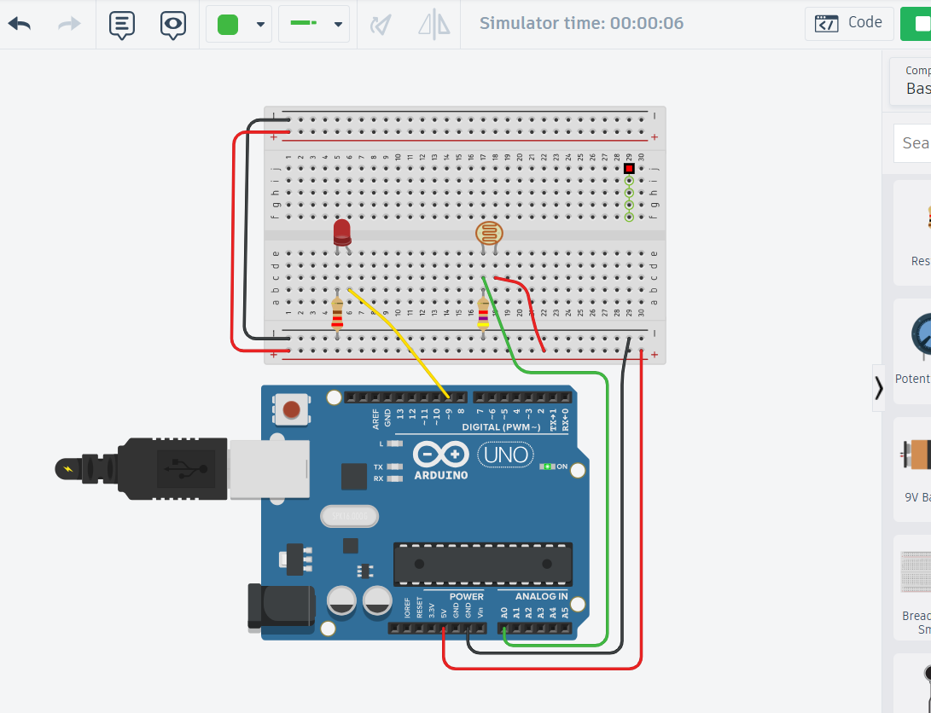

Code:
int ldrPin = A0; // LDR connected to analog pin A0
int ledPin = 9; // LED connected to pin 9

int ldrValue = 0; // Variable to store LDR reading

void setup()
{
pinMode(ledPin, OUTPUT);
Serial.begin(9600);
}

void loop()
{
ldrValue = analogRead(ldrPin);

Serial.println(ldrValue);

// Adjust threshold according to your circuit
if (ldrValue < 500)
{
digitalWrite(ledPin, HIGH); // Dark -> LED ON
}
else
{
digitalWrite(ledPin, LOW); // Bright -> LED OFF
}

delay(100);
}

